Simple Jumps
A Simple Platformer

Project Overview

High Concept and Mockup
Simple Jumps is a 3rd person platformer where the player must make their way across multiple obstacle courses with increasingly difficult. The course ends when the player collects the trophy at the end. If the player falls, they land on spikes that decrease their health and must make their way back to a checkpoint. If the player loses all their health, they lose the game and must restart from the beginning.

Character
You play as Bob, a parkour expert that is ready for his most difficult and dangerous challenge yet.

Camera
A simple third-person camera will be implemented, as to make it easier for the player to survey their surroundings and future challenges in the course.

Controls
The player will use WASD to move and Spacebar to jump. They will move the mouse to rotate the camera.

Game States
Each section or phase of your game, such as a main menu, a battle, overworld navigation, or credits screen, should be described below. Each section should be accompanied by a UI wireframe, indicating what UI elements are needed and their positions on the screen.
You will need at least the following: a Splash Screen, a Main Menu, and a Gameplay screen; sections for each are added below. If your game will have more, please add new sections for them.

Splash Screen
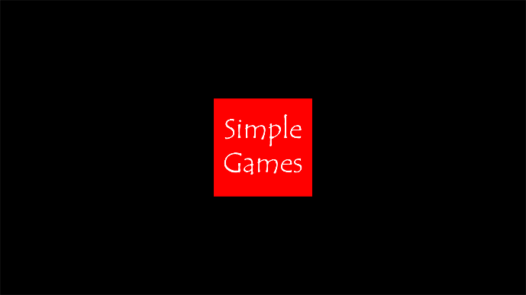
The game will start with a black splash screen with the unreal engine logo to show what it was made in, and then that will fade into black, and the Simple Games company logo will fade in and stay for a few seconds before fading out again.

Main Menu
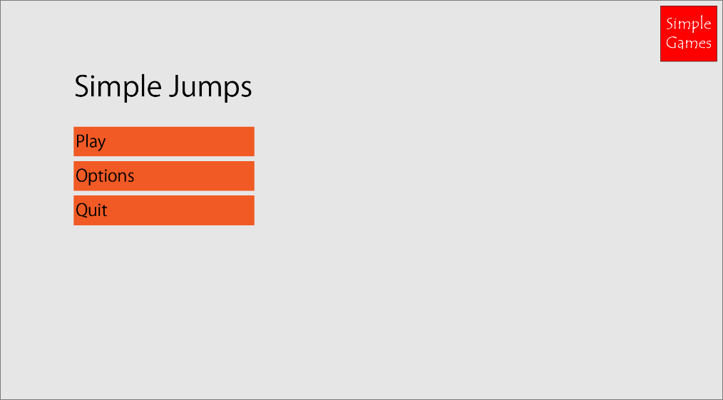

Gameplay
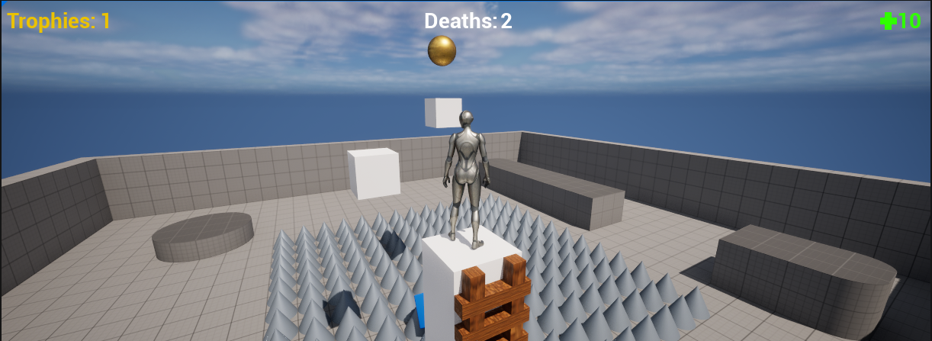
Includes a first basic level as well as the player’s health in the top right corner of the screen. There is a ladder at the beginning platform so that the player can get back if they fall. When the player reaches a checkpoint, a ladder falls to the bottom so that the player can get back up at the checkpoint instead of at the beginning. It also includes a death counter in the top center of the screen as well as a trophies collected count in the top left.

Roadmap
Provide an overview of the time taken to create this project and the objectives that will be completed by each section of time. (This doesn’t need to be super detailed – bullet points and lists will do fine)
Week | Objectives
1 | First Level, Health Mechanics, Spike Functionality
2 | Death Counter, Trophy Counter with Trophy Actor

Credits
Callum Wyndham – Lead Programmer

Flowcharts
Health Flowchart:
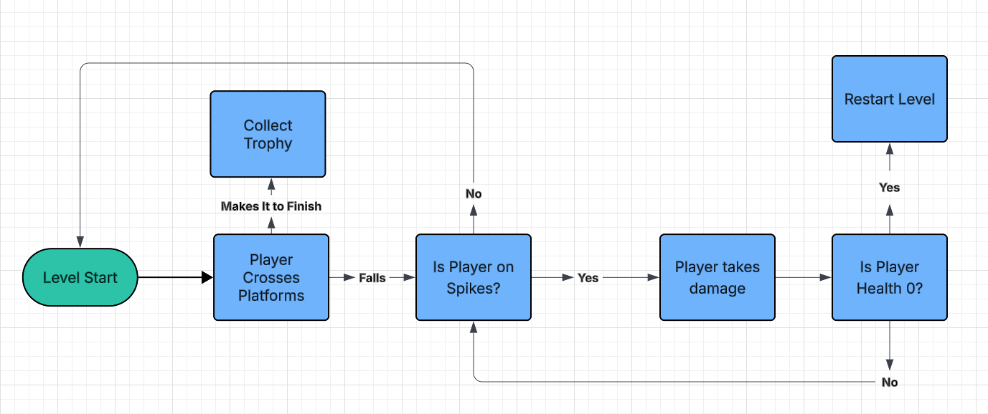Trophy Flowchart:
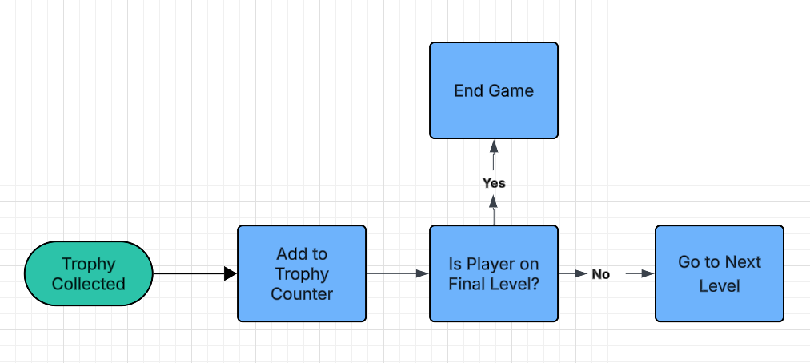

Pseudocode
Death Counter Pseudocode:
BEGIN
GET current death count FROM HUD
SET current death count = current death count + 1
END

